Given the Friedmann equations
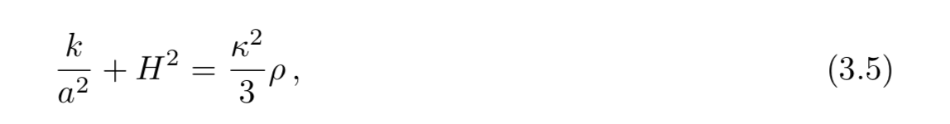
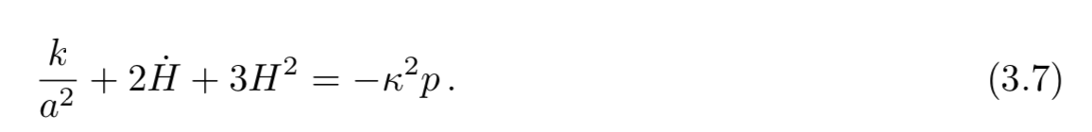, where (3.5) and (3.7) represents the time and spacial components of the equations, respectively, and

$$H=\frac{\dot{a}}{a} \left(3.8\right), \dot{H}=\frac{dH}{dt}=\frac{d}{dt}\left(\frac{\dot{a}}{a}\right)=\frac{\ddot{a}}{a}-\frac{{\dot{a}}^{2}}{a^{2}} (3.9)$$

one can arrange (3.5) and (3.7), namely the operation 0.5*(3.7) -0.5*(3.5), to find

$$\frac{1}{2}\left(\frac{k}{a^{2}}+{2\left(\frac{\ddot{a}}{a}-\frac{{\dot{a}}^{2}}{a^{2}}\right)+3\frac{\dot{a}}{a^{2}}}^{2}\right)-\frac{1}{2}\left(\frac{k}{a^{2}}+{\frac{\dot{a}}{a^{2}}}^{2}\right)=-\frac{κ^{2}}{2}p-\frac{κ^{2}}{6}ρ (3.10)$$

$$\frac{\ddot{a}}{a}=-\frac{κ^{2}}{6}\left(ρ+3p\right) (3.11)$$

Which is the acceleration equation. From the equation one knows that for the universe to expand accelerated-ly, $\ddot{a}>0$, $ρ+3p<0$ and hence $w_{eff}=\frac{p}{ρ}<-\frac{1}{3}$, where $w_{eff}$is the equation of state for a barotropic fluid.

Additionally, considering the derivative of (3.5) in time

$$-2\frac{k}{a^{2}}\frac{\dot{a}}{a}+2\frac{\dot{a}}{a}\left(\frac{\ddot{a}}{a}-\frac{{\dot{a}}^{2}}{a^{2}}\right)=\frac{κ^{2}}{3}\dot{ρ} (3.12)$$

and 3*(3.5) -(3.7) one finds

$$\frac{3k}{a^{2}}+\frac{3{\dot{a}}^{2}}{a^{2}}-\frac{k}{a^{2}}{-2\left(\frac{\ddot{a}}{a}-\frac{{\dot{a}}^{2}}{a^{2}}\right)-\frac{3\dot{a}}{a^{2}}}^{2}=κ^{2}\left(p+ρ\right) (3.13)$$

$$\frac{2{\dot{a}}^{2}}{a^{2}}-2\left(\frac{\ddot{a}}{a}\right)+\frac{2k}{a^{2}}=κ^{2}\left(p+ρ\right) (3.15)$$

,when (3.15) is substituted in by (3.12), gives

$$\left(-\frac{κ^{2}}{3}\dot{ρ}H\right)=κ^{2}\left(p+ρ\right) (3.16)$$

$$\left(\dot{ρ}\right)=-\frac{{3κ}^{2}}{H}\left(p+ρ\right) (3.17)$$

, which is the energy-momentum conservation equation for a barotropic fluid. One then substitutes$p= w_{eff}ρ$into (3.16) to find

$$\left(\dot{ρ}\right)=\frac{{-3κ}^{2}}{H}\left( w_{eff}ρ+ρ\right) (3.18)$$

$$ρ\left(t\right)=ρ_{0}a^{-3\left(1+w_{eff}\right)} (3.19)$$

.
At $w_{eff}=-1, ρ(t)=undefined$, the acceleration region is defined by $-1<w_{eff}<-1/3$.

Regarding the parameters of the dynamical system $x$ and $y$, they are derived from the energy density of the homogenous scalar field $ρ\left(ϕ\right)=\frac{1}{2}{\dot{ϕ}}^{2}+V(ϕ)$ and defined to be

$$x=\frac{κ\dot{ϕ}}{\sqrt{6}H} \left(3.20\right), y =\frac{κ\sqrt{V}}{\sqrt{3}H} (3.21)$$

, where $κ$ is the gravitational coupling constant and $H$ is the Hubble constant. Since the nature of the dynamical system is that of a Friedmann–Robertson–Walker flat spacetime, in which k=0 , re-expressing the Friedman equation (3.5) and defining the densities of matter and scalar field $ρ=ρ_{m}+ρ_{ϕ}=ρ_{m}+\frac{3H^{2}}{κ^{2}}(x^{2}+y^{2} )$ yields

$$H^{2}=\frac{κ^{2}}{3}\left(ρ_{m}+\frac{3H^{2}}{κ^{2}}\left(x^{2}+y^{2} \right)\right) (3.22)$$

$$1=\frac{κ^{2}}{3H^{2}}\left(ρ_{m}\right)+x^{2}+y^{2} (3.23)$$

$$1=\frac{κ^{2}}{3H^{2}}\left(ρ_{m}\right)+x^{2}+y^{2} (3.24)$$

,where $\frac{κ^{2}}{3H^{2}}\left(ρ_{m}\right)$= relative energy density of matter and $x^{2}+y^{2}$= energy density of scalar field. Because the energy density of matter is positive, this means that
$$0≤ 1-\frac{κ^{2}}{3H^{2}}\left(ρ_{m}\right)=x^{2}+y^{2}≤1 (3.25)$$
. Therefore, only a bounded region in the form of a semi-circle spanning the +y axis is a mathematically meaningful region because the universe is expanding, and not the other way around (y<0).

Furthermore, x and y represents the kinetic and potential energy of the scalar field contributing to universe’s expansion, respectively, with y being effectively a cosmological constant that contributes to the accelerated expansion of universe. Therefore, we could classify the current evolution of the universe by the following:

- If $x>y$, kinetic energy of scalar field dominates
- If $y>x$, the potential of scalar field dominates
- If $y=0, x=0$, matter field dominates.

To see this further, consider the effective Equation of State(EOS),
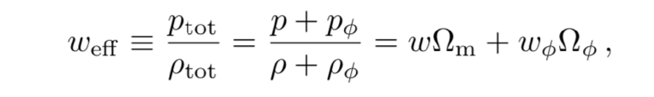

, where $w$ and $w_{ϕ}= \frac{x^{2}-y^{2}}{x^{2}+y^{2}}$ are the equation of state of matter and scalar field, respectively. This can be simplified to give

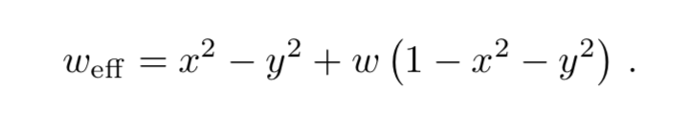

As mentioned before, the expansion of the universe is accelerating for $w_{eff}<-\frac{1}{3}$ and de-accelerating for $w_{eff}>-\frac{1}{3}$ . For example, looking at the fixed points of the dynamical system, if $O=\left(x,y\right)=(0,0)$ , then $w_{eff}=w$ and the universe would be matter dominated. If $A_{±}=\left(x,y\right)=\left(±1,0\right)$, then $w_{eff}=1$, and the universe is dominated by the kinetic energy of scalar field which behaves as a stiff matter fluid ($w=1$) and de-accelerates. If $P=\left(x,y\right)=\left(0,1\right)$ (non-fixed point), then $w_{eff}=-1$ and the universe is dominated by the potential energy of the scalar field which behaves as an effective cosmological-constant facilitating inflation, fitting the slow-roll condition which states that there will be inflation if scalar field potential is flat enough and much larger than the scalar field kinetic energy.

The derivative of x and y w.r.t the logarithm of the scale factor $N=\ln\left(a\right)$ gives
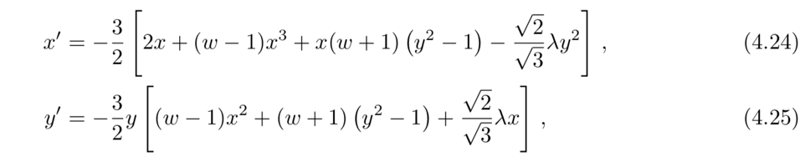
.

Here, $λ$ is a variable that corresponds to scalar field potential given by $V\left(ϕ\right)=V_{0}e^{-λκϕ}$ which determines the flatness of the potential. The slow roll condition is fulfilled (scalar field potential is flat enough for the universe to undergo inflation forever) when $λ≤\sqrt{2}$. It’s worth to note that when $λ→0$ the potential is flat and reduces to $w_{eff}=-1$, showing that the universe is dominated by dark energy and cosmological constant.
To analyze the Phase-Portrait, one looks at the diagram for different values of $λ$ while keeping $w=0$ because this simplifies the expression of $w_{eff}$, rendering it more convenient to analyze the transition of the Equation of state to dark energy and matter. The qualitative behavior of the diagram can be classified into three regions according to the values of $λ^{2}$: to ${0≤λ}^{2}≤3(1+w)$, ${3(1+w) ≤λ}^{2}≤6$ to ${6 ≤λ}^{2}≤∞$.

Region 1: ${0≤λ}^{2}≤3(1+w)$

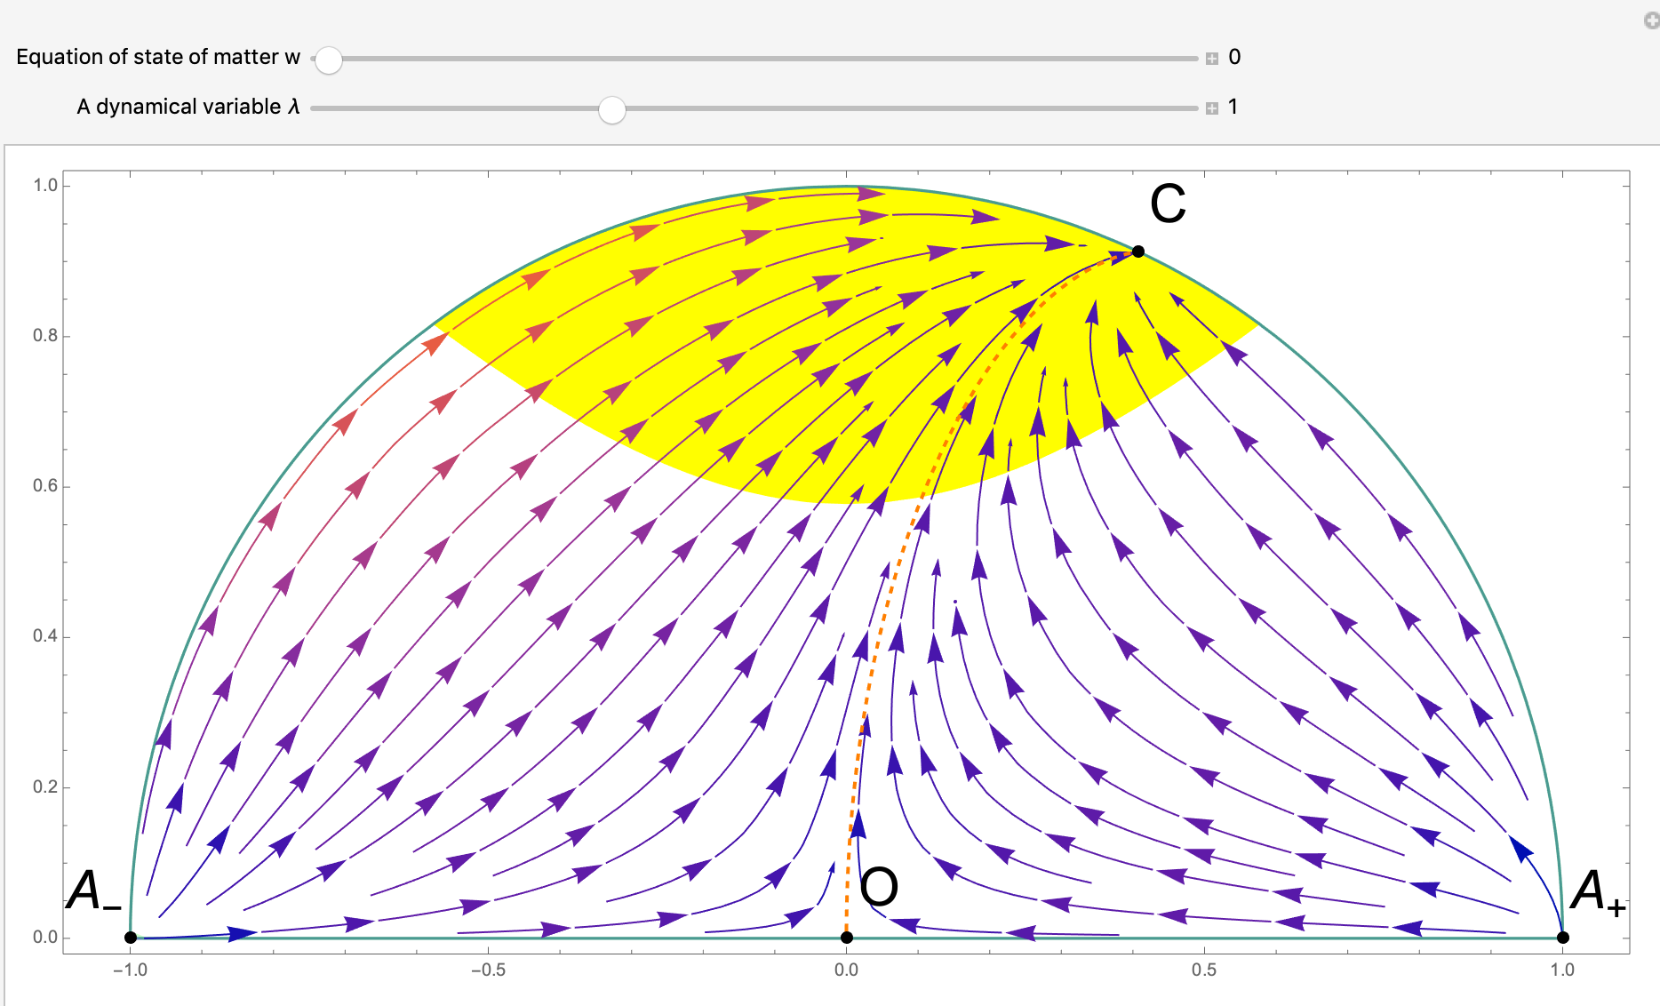

- Four critical points. Point $A_{±}$ are unstable nodes, Point $O$ is a saddle point.
- Because $λ^{2}<2$ represents a cosmological inflationary solution, for $λ^{2}=1$ the stable trajectories approach the acceleration region colored in yellow.
- All trajectories in diagram follow heteroclinic orbits starting from point $A_{±}$ to point $C$, except trajectories on the $x$ axis connecting $A_{±}$ to $O$ and the orbit connecting $O$ to $C$.
- Last trajectory divides the diagram into 2 invariant sets, the trajectories on the left originated from point $A_{-}$ as their past attractor, while those on the right originated from point $A_{+}$ as their past attractor. Thus there are 2 heteroclinic sequences, namely, $A_{±}→O→C$.
- The past attractors $A_{±}$ features an universe dominated by stiff-fluid which is phenomenologically unfavored
- The large-time attractor corresponds to an effective EOS $w_{eff}=-1+\frac{λ^{2}}{3}$.

Region 2: ${3(1+w)≤λ}^{2}≤6$

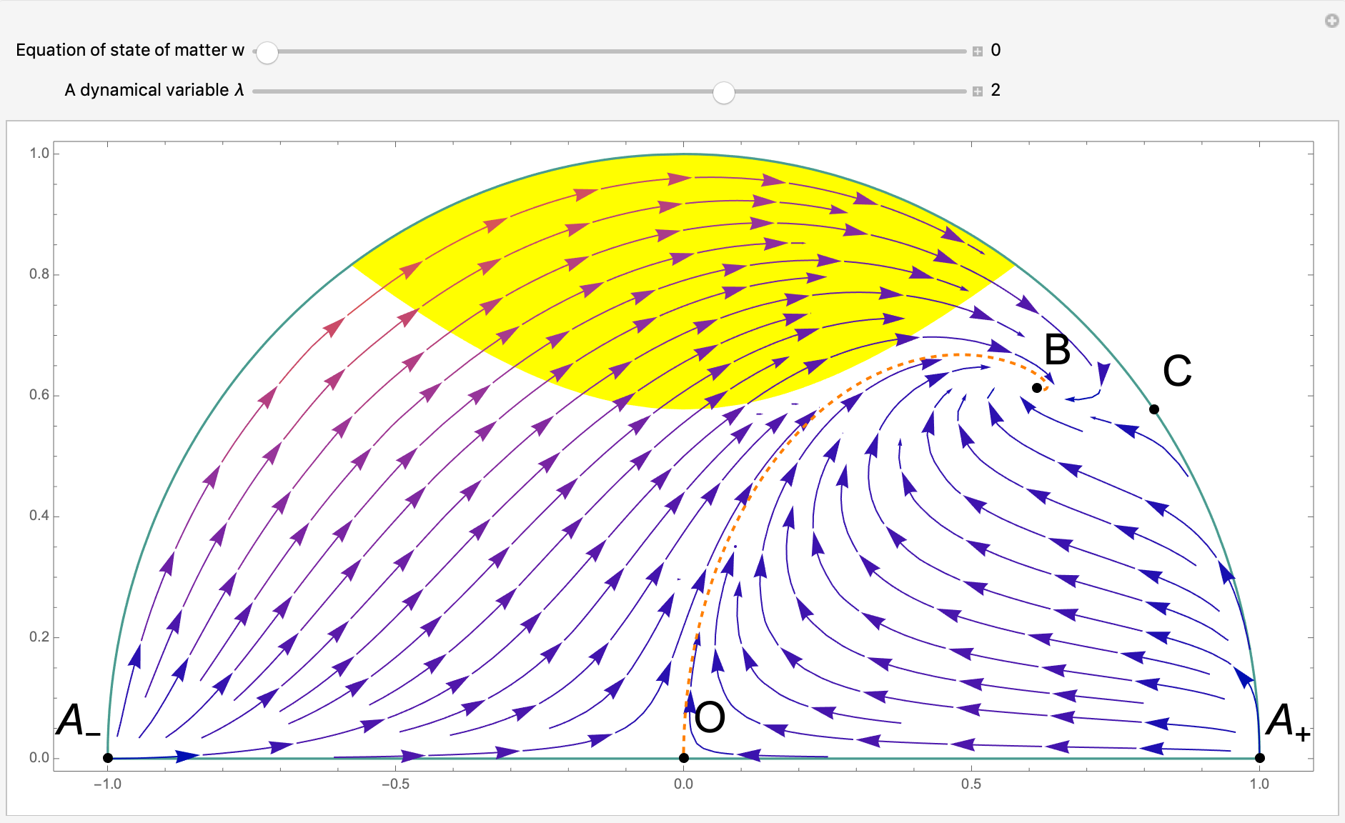

- Five critical points. Point $A_{±}$ are unstable nodes, Point $O$ is a saddle point.
- $B$ is a large-time attractor, and Point $C$ is a saddle point.
- The large time attractor is outside the acceleration region and does not feature an inflationary universe.
- The Effective EOS $w_{eff}={x_{ }^{2}}_{B}-{y^{2}}_{B}+w\left(1-x^{2}-y^{2}\right)={\left(\sqrt{\frac{3}{2}\frac{\left(1-w^{2}\right)}{2λ^{2}}}\right)}^{2}-{\left( \sqrt{\frac{3}{2}\frac{\left(1-w^{2}\right)}{2λ^{2}}}\right)}^{2}+0=0$ coincides with the matter EOS $w=0$, thus solution is matter-like, even though the universe’s expansion is not dominated by matter due to non-zero $λ$ which shows the presence of scalar field. This is known as scaling-solution.
- All trajectories in diagram follow heteroclinic orbits starting from point $A_{±}$ to point $B$, except trajectories on the boundary connecting $A_{±}$ to $O$ and $C$, and the 2 orbits connecting $A_{±}$ and $C$ to $B$.
- Last trajectory divides the diagram into 2 invariant sets, with point $A_{-}$ and point $A_{+}$ as their past attractors.
- There is a transition of trajectories into inflationary periods dominated by dark energy, when they cross the acceleration region.
- When $λ→\sqrt{3}$, point $B$ and $C$ merges into a single point (bifurcation), and the heteroclinic orbits undergoes a temporary period of inflation starting from matter ($O)$ to scaling ($B)$ solution.

Region 3: ${6 ≤λ}^{2}≤∞$

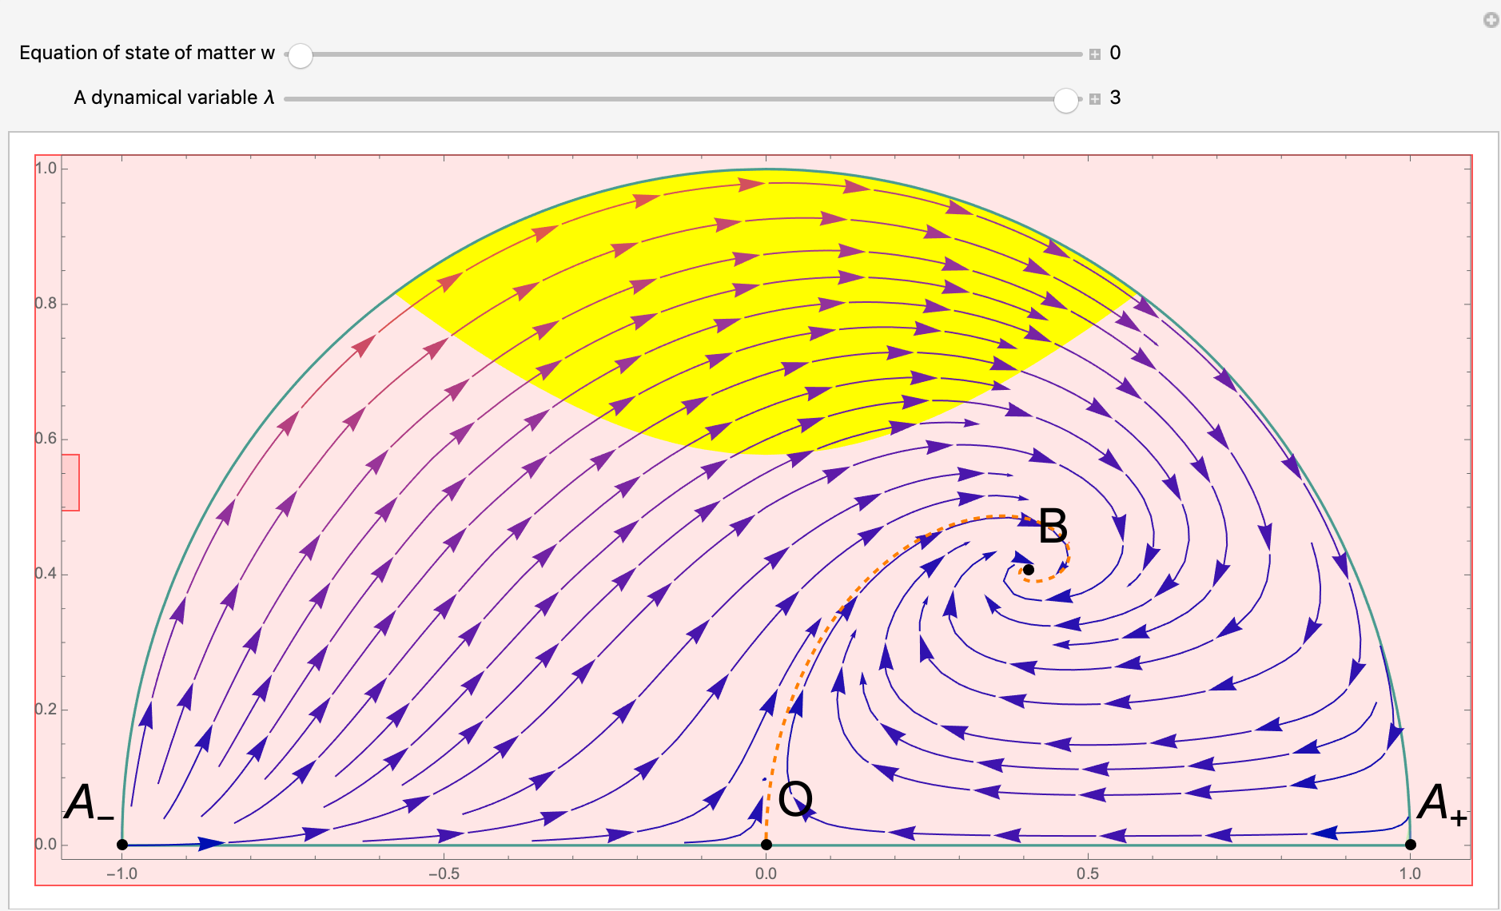

- Four critical points. Point $A_{-}$ is an unstable node, and Point $A_{+}$ and Point $O$ are saddle points. Note that Point $C$ disappears.
- $w_{eff}=w$ means that universe evolution under the scaling solution, with $B$ being the large time attractor.
- All orbits start from $A_{-}$ as past time attractor to $B$, which is a stable node for $3\left(w+1\right)<λ^{2}<\frac{24{\left(w+1\right)}^{2}}{9w+7}$ and an attracting spiral for $λ^{2}>\frac{24{\left(w+1\right)}^{2}}{9w+7}$
- Few heteroclinic orbits connecting $A_{-}$ $→A_{+}→O→B$.
- For $λ→∞$, $B=\left(\sqrt{\frac{3}{2}}\frac{\left(1+w\right)}{2λ^{2}},\sqrt{\frac{3}{2}\frac{\left(1-w^{2}\right)}{2λ^{2}}}\right)$ will approach the origin and coincide with $O$. This also indicates that $V\left(ϕ\right)→0$. Matter dominated universe.

According to current theory of cosmology, the early universe should undergo an extremely short period of inflation, followed by a long period of matter domination and then inflation. Therefore, Region 1 best fits our current theory of cosmology because $λ^{2}=1<2$means that scalar field potential is flat enough for slow-roll condition to be fulfilled. However, it’s not viable for the universe to start out as being stiff matter fluid dominated, thus only the matter (ordinary and dark) to dark energy transition is allowed phenomenologically. Additionally, the above model does not show when is the transition between matter to dark energy. However, this model is simplistic and fairly accurately reflects the evolution of the universe characterized by exponential potential.
